

**DIG2632 CMG Brainstorm**

**STEP ZERO: GAME TITLE/IDEA**

Bridg3D

**STEP ONE: INSPIRATION**

Play the three student games in the Canvas Files Week One folder, and play or watch online play streams of games/media that resonate or inspire the type of game you would like to develop. **List your top 2-3 media sources** that drive your gameplay vision?

1. Castle Crashers (gameplay/weapons/health/coins)

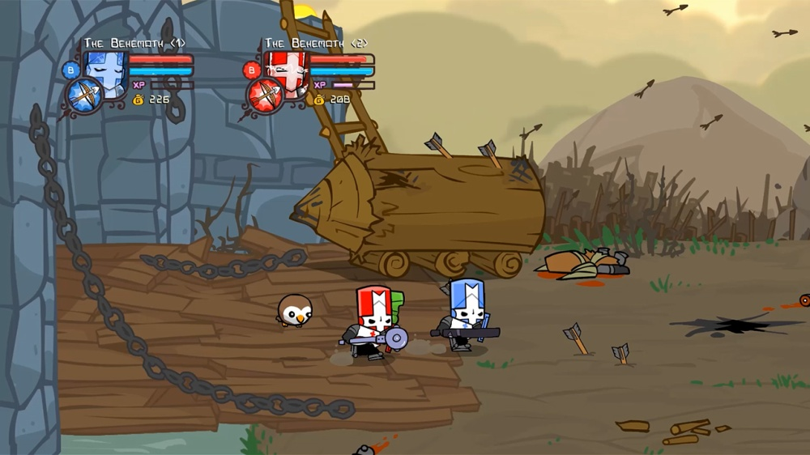

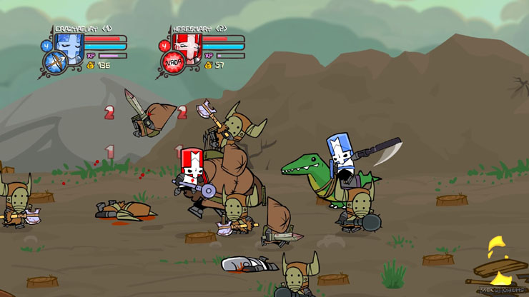

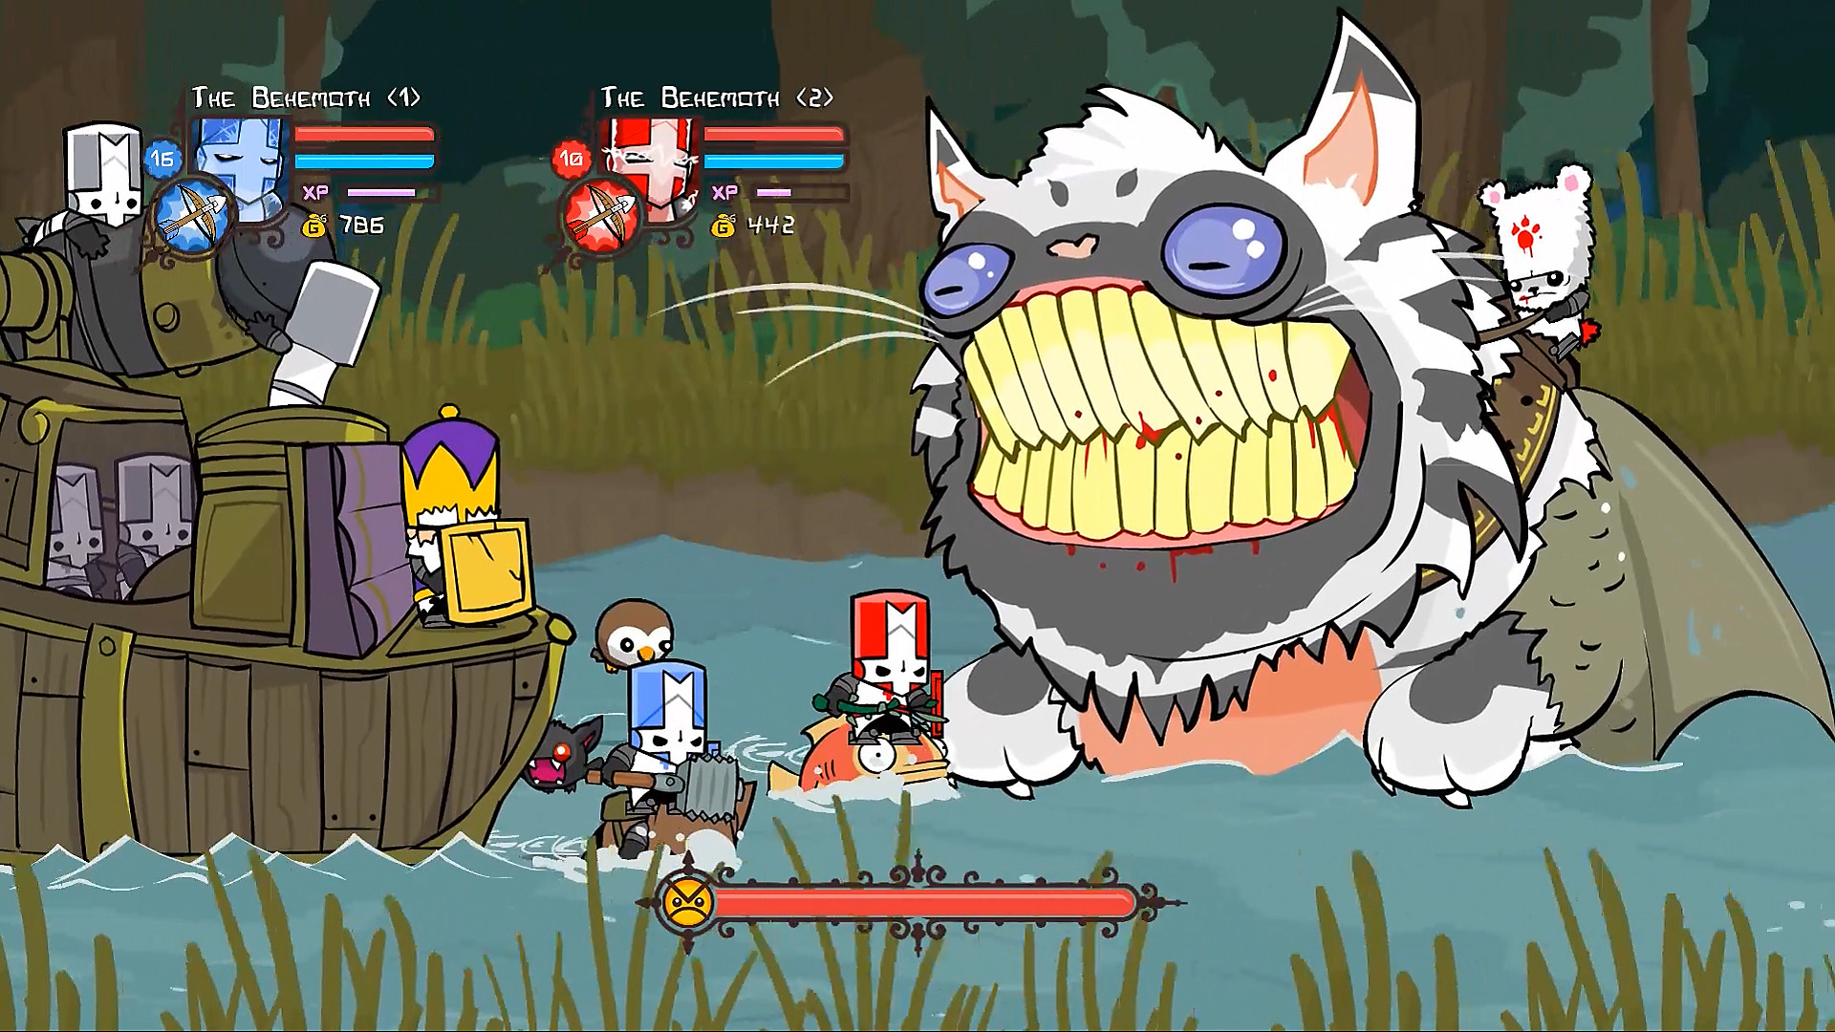

1. Call of Duty Zombies (waves/upgrades/various enemy types)

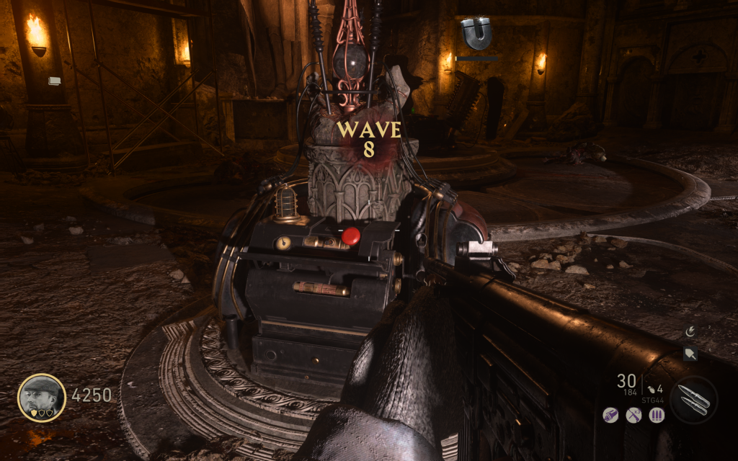

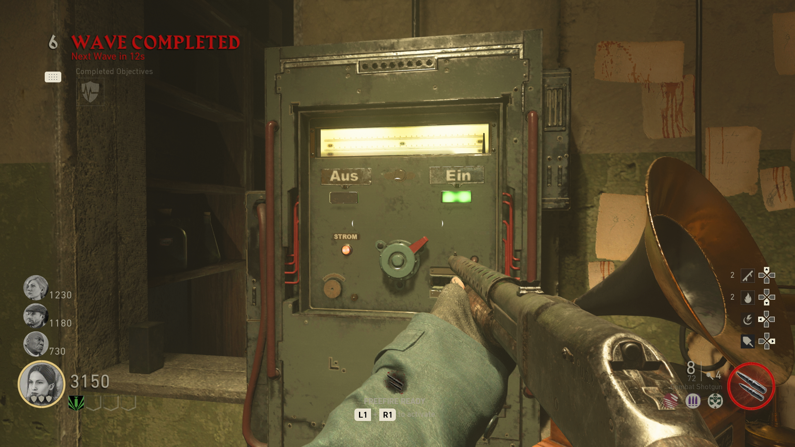

1. Bloons Tower Defense (upgrades/shop/health of home base)

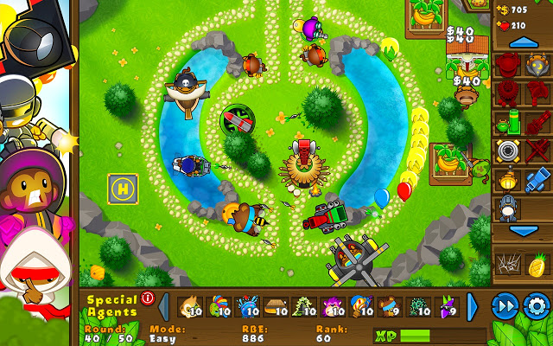

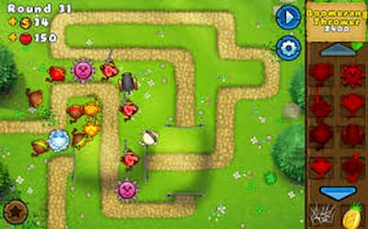

1. Bit Battles (knockback/variety of enemies/upgrades/health of home base)

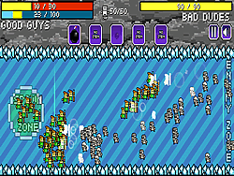 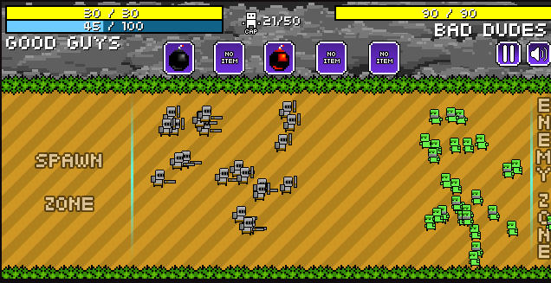

1. Mordhau (gameplay/weapon attacks/first person camera)

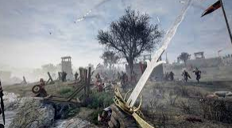 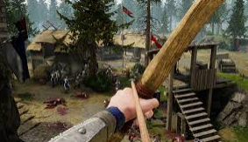

**STEP TWO: GAME TYPE**

Decide on your game’s camera – **2D side-view** *(default and in class demos)* or **2D top-down** *(not demoed and more challenging to design and create for).*

* 3D first person, 3D static level with waves approaching from one side, weapon animations should be seen from player POV and should slash enemies as expected based on view

**STEP THREE: GENRE**

What will the focus of your gameplay be? *(Examples; Educational, Role-Playing, Shooter, Adventure, Bullet-Hell, Exploration, Story-Driven, etc. – also – you can mix these for a hybrid genre like Educational Story-Driven, or Role-Playing Bullet-Hell).*

* Wave defense, upgrades, boss fights, medieval style combat (melee and ranged), drops/collectibles, endless
* Set somewhat historically (explained more in Stretch Goals) in the Viking Age
* Should have feel good combat systems that are at least semi-physics based

**STEP FOUR: MECHANICS and SYSTEMS**

With your type and genre more defined, and looking at the games that inspire you, what gameplay mechanics and/or systems will you need to make it happen. **List and prioritize them** *(Examples; dialogue, hazard, incremental damage, double-jump, grappling hook, bounce physics, phase/state changes, Player metamorphosis, etc.).*

* Probably low poly but stylistic, perhaps textured with pixel art – easier to animate plus gives a retro feel to the game
* Wave defense with varied enemy types (basic melee enemy, stronger melee enemy, basic range enemy, stronger range enemy, fast but weak enemy, slow but strong enemy, etc.)
* Mini boss fights and boss fights – varied boss types with attack cycles and abilities
* STRETCH: Cutscenes (to introduce story of game at beginning and at critical moments when new abilities are introduced) [with option to skip if player just wants to jump right into the action]
* Drop/loot/collectible system with market/upgrade system as well (upgrades can impact player’s stats as well as perhaps enemy stats [almost like sabotage/poison the enemy for the next 3 waves or something])
* STRETCH: Various weapons to use, both melee and ranged, with different stats regarding damage, range, attack speed, knockback
* If enemies reach a certain point, they begin attacking “home base”, “home base” must survive (or perhaps if destroyed then no more upgrades/market, giving incentive to protect even though technically not necessary)
* Types of armor (shield mechanics [including durability maybe?], resistance to damage and speed effects)
* Health / ways to restore health
* Action packed music for during the wave and calmer music for between waves
* Sound effects for weapons, enemies, kills, loot, purchases
* Smooth animations – with lots of combat going on with many types of enemies/weapons, animations will be a big part in making it flow together well, so having good art/animations/particles is essential
* Enemy pathfinding within level

**STEP FIVE: GDD STRETCH GOALS**

Historically based in Battle of Stamford Bridge in England in 1066 between Vikings under Harald Hardrada and English under Harold Godwinson. One Viking (armed with an axe) held on the bridge (the choke-point of the area) alone against the English to buy time for the Vikings to regroup and form a shield wall. He killed about 40 English and was only killed when one English soldier went under the bridge and attacked him from below.

While this game will not be entirely historically accurate, it is based upon this legend and the player will control this character.

<https://en.wikipedia.org/wiki/Battle_of_Stamford_Bridge#Battle>

The player’s character is named Ragnar Eriksson, born and raised in Norway and fiercely loyal to his commander, Harald Hardrada. He is big and strong and armed with an axe, and willing to lay down his life defending the bridge to allow his fellow troops to retreat and regroup. After the first wave of attackers, the English rebel George Williams arrives to sell you upgrades and provisions to allow you to keep fighting against the English for as long as possible.

The mechanic regarding the health of Williams’ market is important, as enemies will target both you and the market. If the market runs out of health, Williams will run away as it is no longer safe for him to stay near you; thus, you will lose the ability to access the market and must finish the game with only the supplies and weapons that you had at the time that he ran away.

At first Godwinson (leader of the English) only sends menial forces against you as you are only one man. After besting his pawns, he realizes you’re a much bigger threat than anticipated and begins ramping up his attacks on you, sending more and more troops along with better and stronger and more specialized troops to take you down. Along the way, Godwinson will send sergeants, lieutenants, and captains (the mini bosses and bosses) against you before he comes out. Each officer will have a special ability and a squad of soldiers to help him defeat you. Ultimately, he will ride into battle against you himself to take matters into his own hands (the final boss). If you beat him, you win the game and have the option of continuing against increasingly difficult waves of enemies until you finally lose.